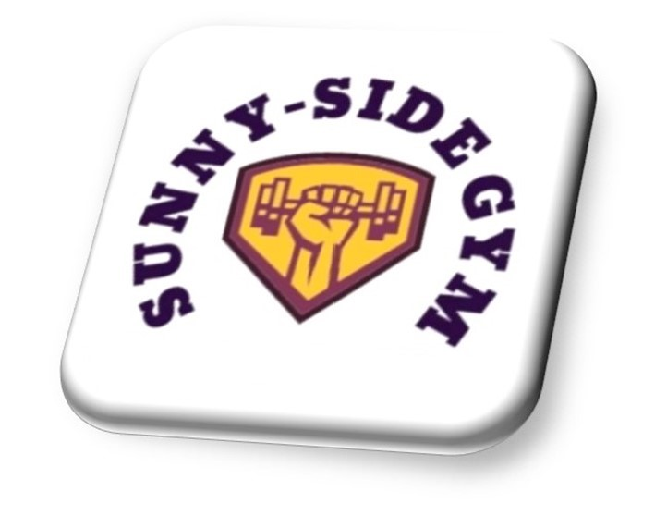

Registration Form

Name: ________________________________________
Contact Tel. No: ________________________________________
Address: ________________________________________
________________________________________
________________________________________
Do you identify as Male/Female
DOB: ________________________________________
Member. No: ________________________________________
Any medical condition: ________________________________________
Current medication: ________________________________________
________________________________________
Next of Kin: ________________________________________
Relationship: ________________________________________
Contact No. ________________________________________

I give permission for Sunny-Side Gym to contact me with the details you provided? Yes/No

Health History (please check boxes as applicable)

Yes/No Do you lose your balance because of dizziness, or do you ever lose consciousness?

Yes/No Has your doctor ever said you have a heart condition and should only do physical activity recommended by a doctor?

Yes/No Do you feel pain in your chest when you do physical activity?

Yes/No Are you being treated for high blood pressure?

Yes/No Do you have diabetes?

Yes/No Do you have asthma or any other respiratory problems?

Yes/No Do you have any bone or joint problems that could be made worse by change in your physical activity?

Yes/No Do you have epilepsy?

Yes/No Do you have a pacemaker?

Yes/No Are you pregnant?

Yes/No Do you know any other reasons you should not engage in physical activity?

If you have answered yes to any of these questions, please add any other information here:

___________________________________________________________________________________
___________________________________________________________________________________
___________________________________________________________________________________

Waiver Issued by: Sunny-Side Gym Ltd, 7/9 Springfield Street Morecambe LA44HA
Name: _____________________________________________________
Address: _____________________________________________________
Member No: _____________________________________________________

By submitting an order, (online or by other means), making an authorisation payment or by using any services supplied by Sunny-Side Gym Ltd trading as Sunny-Side Gym, the Customer agrees to Sunny-Side Gym Ltd Terms of Service (TOS) and Privacy Policy.
Express assumption of risk:
I, the undersigned, am aware that there are significant risks involved in any physical training regimen. These risks include but are not limited to: falls which can result in serious injury or death; injury or death due to negligence on the part of myself, my training partner, or other people around me, injury or death due to improper use or failure of equipment. Injury may also result simply from the fact of physical training itself.
By its very nature, physical training seeks to have me push beyond my physical and mental limits in order to produce a physical adaptation by my body. Excessive work can result (in rare cases) in exertional rhabdomyolysis. I should look for signs of excessive soreness, darkened urine, and pain in the kidney areas in the days following a particularly intense workout. While this type of injury is rare, it can occur due to a number of factors, including (but not limited to) genetic predisposition, medication, or other factors that are beyond the control of my trainer. I am aware that any of these above mentioned risks may result in serious injury or death to myself and or my partner(s).
I willingly assume full responsibility for the risks that I am exposing myself to and accept full responsibility for any injury or death that may result from participation in any activity or class while training at or with Sunny-Side Gym Ltd.
I, the undersigned, acknowledge that I have no physical condition, illness, or impairment that I know of that will endanger myself or others.
Release of liability:
In consideration of the above mentioned risks and hazards and in consideration of the fact that I am willingly and voluntarily participating in the activities available at Sunny-Side Gym ltd, I, the undersigned hereby release Sunny-Side Gym Ltd, Inc., its officers and directors, and Sunny-Side Gym Ltd their principals, agents, employees, and volunteers from any and all liability, claims, demands, actions or rights of action, which are related to, arise out of, or are in any way connected with my participation in this activity, including those allegedly attributed to the negligent acts or omissions of the above mentioned parties.
I affirm that I have stated all my known medical conditions and answered all questions honestly. I agree to keep Sunny-Side Gym ltd updated as to any changes in my medical profile and understand that there is no liability on Sunny-Side Gym Ltd part should I fail to do so.
This agreement shall be binding upon me, my successors, representatives, heirs, executors, assigns, or transferees. If any portion of this agreement is held invalid, I agree that the remainder of the agreement shall remain in full legal force and effect.
Indemnification:
The participant recognizes that there is risk involved in the types of activities offered by
Sunny-Side Gym Ltd. Therefore, the participant accepts financial responsibility for any injury that the participant may cause either to him/herself or to any other participant due to his/her negligence. Should the above-mentioned parties, or anyone acting on their behalf, be required to incur attorney’s fees and costs to enforce this agreement, I agree to reimburse them for such fees and costs. I further agree to indemnify and hold harmless Sunny-Side Gym Ltd, their principals, agents, employees, and volunteers from liability for the injury or death of any person(s) and damage to property that may result from my negligent or intentional act or omission while participating in activities offered by Sunny-Side Gym Ltd.

Signed: _____________________________ Date: ____________________________

